Game information and specifications

Target audience:

We will primarily be going for younger males however it will probably be more unisex. As we don’t want to exclude people from playing our game. The design of the game will be rather unisex however discussed the possibility of adding gore however this would possible bring up the age of the target audience

Genre:

The genre of the game is going to be an action arcade game. The whole premise of the game is to increase your score and beat you friend to get the highest one. You get your score based on how far you travel to the right.

Platform:

The platform shall be PC as everyone owns one of some description and our game shouldn’t be too demanding on hardware. The game should come in a executable format and not be too demanding on space.

Existing similar games:

Toss the turtle

In this game, you fire a turtle character with a canon and try and get it as far as possible this game has sequels so it must be quite popular. The game is a fair bit gory but being quite entertaining in my bias opinion

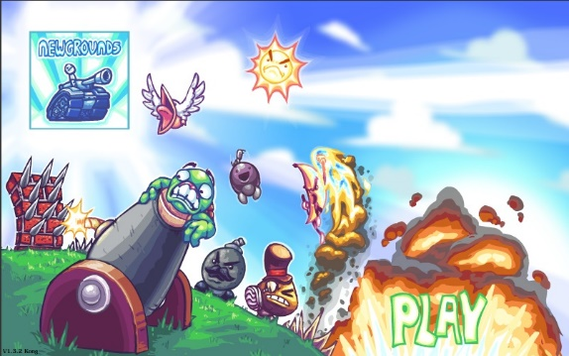

Angry Birds

I very much enjoyed this game when I was younger as I had to think tactically to knock down structures to wipe out enemy pigs it has a similar catapult mechanic to our first prototype.

Flappy Bird

This an arcade style game which is rather like the prototype. In this game you want to avoid obstacles in order to get a high score your score increase with each obstacle you clear.